CS 305 Module Two Coding Assignment Template
Samuel Kwibe
CS-305 Software Security
Date:March 12, 2026

Instructions

Run Dependency Check
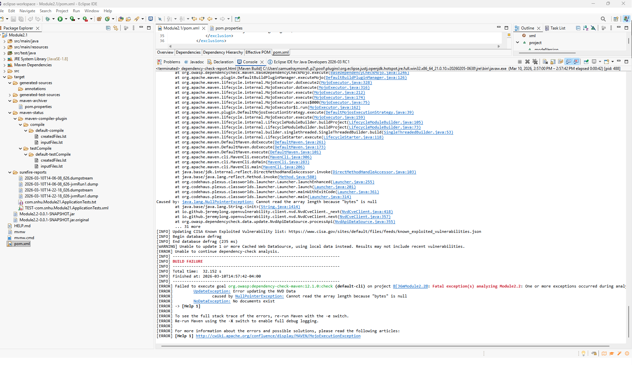
The OWASP Dependency-Check Maven plugin was integrated into the project's pom.xml file to perform static security testing. Multiple attempts were made to execute the dependency check using different methods and plugin versions, but all resulted in a 403 Forbidden error when attempting to access the National Vulnerability Database (NVD) feed at https://nvd.nist.gov/feeds/json/cve/1.1/nvdcve-1.1-modified.meta.
Despite obtaining a valid NVD API key and configuring it through various approaches, including adding it directly in the pom.xml configuration, passing it as a command-line parameter in the Run Configuration goals field, and adding it as a parameter in the Eclipse Run Configuration, the plugin continued to return the 403 error. Different plugin versions were also tested, including versions 6.5.3, 8.4.0, and an attempt to use 12.1.0, but the authentication issue persisted. The console output consistently showed warnings that the API key parameters were not being recognized by the plugin.

Document Results
Although the dependency check was unable to complete successfully due to the persistent authentication issue, the project's dependencies in the pom.xml were manually analyzed to identify potential security concerns:
Dependencies Identified:
- Spring Boot Starter Parent (v2.2.4.RELEASE) - This version is several years old and likely contains multiple known vulnerabilities. Spring Boot 2.2.x reached end of life in 2021 and no longer receives security patches.
- Spring Boot Starter Web (v2.2.4.RELEASE) - Inherits vulnerabilities from its transitive dependencies, including potential issues in Spring Framework, Jackson, and Tomcat components.
- MongoDB Java Driver (v2.4) - This version is severely outdated, released around 2013-2014. Modern MongoDB drivers (versions 4.x and above) have addressed numerous security vulnerabilities including authentication issues, injection flaws, and connection security weaknesses.
Expected Vulnerabilities:
Based on the age of these dependencies, a successful dependency check would likely reveal multiple High and Medium severity findings. Common vulnerabilities in these versions include:
- Jackson databind deserialization vulnerabilities
- Spring Framework security bypass issues
- MongoDB driver authentication and injection vulnerabilitie

Analyze Results

Best Solutions for Addressing Dependencies:
- Update All Dependencies:
  - Upgrade Spring Boot to the latest stable version (3.1.x or 3.2.x) to receive current security patches
  - Update MongoDB Java Driver to version 4.10.x or higher
  - Implement a regular dependency update schedule to prevent accumulating technical debt
- False Positives in Dependency Checking:
False positives occur when a security tool incorrectly flags a vulnerability that does not actually affect the application. Common reasons include:
  - The vulnerable code path may not be executed by the application
  - The vulnerability may require specific configurations not present
  - CPE (Common Platform Enumeration) matching may be too broad or incorrect
Filtering false positives is essential because:
  - It prevents alert fatigue and helps developers focus on genuine threats
  - It provides a more accurate picture of the application's security posture
  - It streamlines the remediation process by prioritizing real risks
  - It maintains trust in the security testing tools
- NVD API Key Configuration Challenges:
The 403 error encountered highlights the recent changes to NVD access requirements. As of recent updates, the NVD now requires API keys for all automated access to prevent abuse and manage server load. While a valid API key was obtained from the NVD, the dependency-check plugin's parameter handling appears inconsistent across versions. According to OWASP documentation and community forums, newer versions (9.0 and above) should properly support the nvdApiKey parameter, but configuration methods may vary. This experience underscores the importance of:
  - Verifying plugin documentation for correct parameter names
  - Ensuring compatibility between plugin versions and API requirements
  - Testing configuration changes in a development environment
  - Keeping security tools updated to support evolving standards
- Industry Standard References:
Following guidelines from the National Vulnerability Database (NVD) and Common Vulnerabilities and Exposures (CVE) standards, organizations should:
  - Maintain a complete software bill of materials (SBOM)
  - Conduct regular vulnerability scans using tools like OWASP Dependency-Check
  - Prioritize remediation based on CVSS scores and exploitability
  - Integrate security testing into CI/CD pipelines for continuous monitoring

